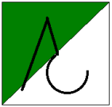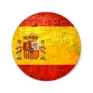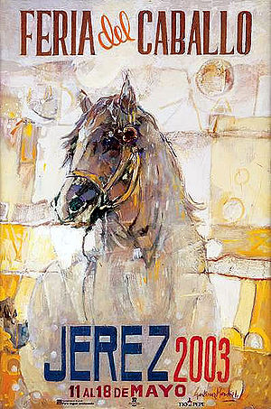

*&* "al-Ándalus" Travesía a Caballo  
 "Wednesday, May 1st to Saturday, May11th, 2024"

Visiting Andalusia in Spain, with its fairs and pilgrimages, is a guarantee of satisfaction for horse lovers. **The Horse Fair of Jerez** is one of the oldest in Spain and undoubtedly one of the most important in the world. Devoted as it is "to the horse," competitions such as "dressage and harness," among many others, are held, making it the largest popular festival of its kind. Visiting the fair is simply having a "great time," in the company of good friends and enjoying an environment where the host is undoubtedly "The Horse," where you can daily enjoy the presence of "hundreds of beautiful horses" and elegant riders and carriages.

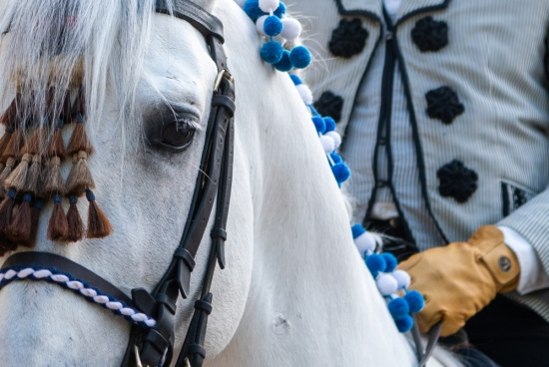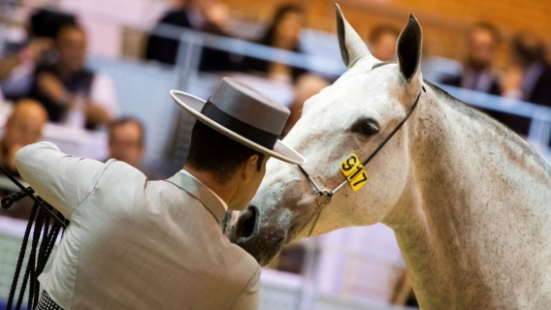

***O***ur exclusive "*al-Ándalus*" program is an excellent opportunity to get to know the most important aspects of horse culture and the history of Andalusia, guiding us through the nature of the Andalusian region, its gastronomy, and its historical heritage. We present a new, more cultural and gastronomic route, with enjoyable gallops on the gentle slopes and vast plains of the northern face of the Sierra Nevada.

We will uncover the history of the "moriscos" who remained in these lands after being expelled from Granada and stroll through small villages that have not changed their appearance since the Arab presence. The Northern Face of the Sierra Nevada, with its varied landscape ranging from the high mountain environment to the fertile Mediterranean valleys.

We will ride through numerous mountain villages that have been meeting points between the Arab and Christian worlds for centuries.

|  |
| --- |
| **-** **Day 1, Wednesday, May 1, 2024**  __________________________________________________________  **12:30 horas Meet & Greet** / Welcome Cocktail in the town of **Cogollos de Guadix**  Located just 75 km / less than 1 hour drive, from the city of Granada.  Reception by the Tour Guide  2:00 PM Welcome Lunch  *Details of the meeting point will be provided upon receiving your reservation.  ____________________________________________________________________  **Cogollos de Guadix** is located on the northern edge of the Sierra Nevada Natural Park, forming part of the mountainous area that the Arabs called Sened. Its magnificent natural surroundings make it the perfect place for horseback excursions in one of the most extraordinary natural spaces in all of Granada:  - Reception and presentation of the horseback excursion.  **- Gastronomic tasting dinner and accommodation at Hotel Reina Aixa.** |

**DAY 2. May 2nd / Thursday (Start of the Journey) Lugros - Shepherd's Path - Pantaneta – Lugros**

Car transfer to the estate to meet our horses. /Approx. 20 minutes

On our first day of the journey, to adapt to our horses, we will traverse an easy trail with marvelous views of the plateau (1200 meters above sea level). We will use the "Shepherd's Path," which winds through dense pine forests. The thickness of these woods, the silence of the trail, and the tranquility of the surroundings allow us to carefully observe every corner and discover the almost magical nature of this forest, known as the enchanted forest. (We can almost sense some "gnome" or fairy from this magical place.)

We arrive at "La Pantaneta," a small lake surrounded by mountains formed by the melting waters of the Sierra Nevada. The more adventurous ones, daring to face the cold water, can take a refreshing swim if they wish.

**Picnic lunch by the Pantaneta de Cogollos.**

**Total duration of the horseback journey / Approx. 4 hours.**

**Dinner and Accommodation: Hotel Reina Aixa.  
 Items included on this day: Breakfast - Private transfer to the estate - Horseback journey - Picnic lunch - Dinner - Accommodation**

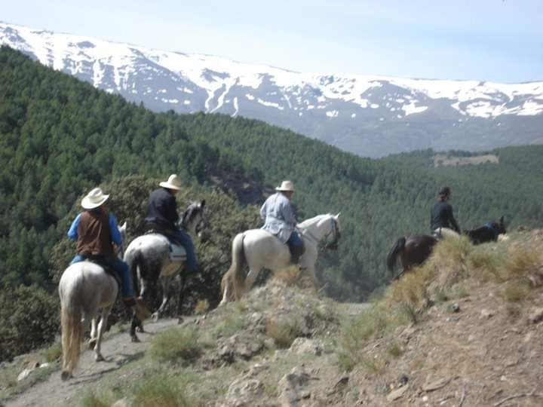

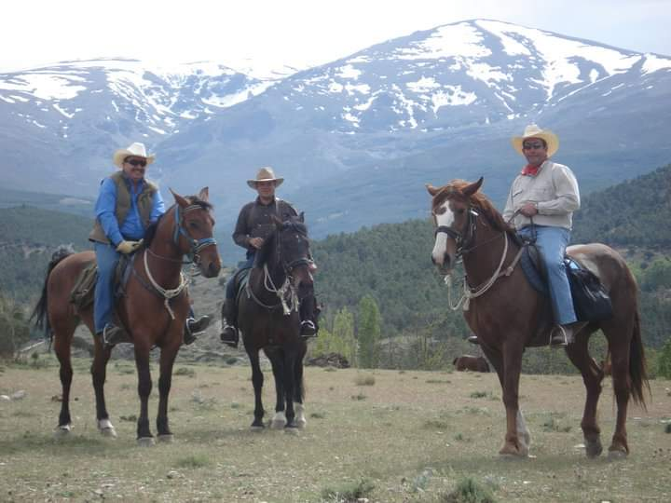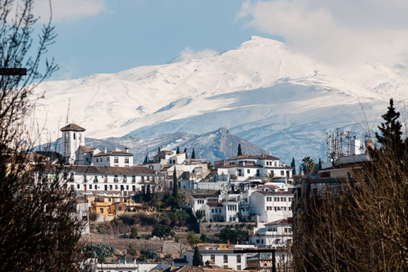

**DAY 3. May 3rd / Friday Lugros - Camarate - Jerez del Marquesado**

After enjoying our breakfast, we set out to explore with our horses. The gentle slopes of these mountains, with easy paths traditionally used for livestock, have allowed the locals to guide their "cows and brave bulls" to the green high-mountain meadows known as "el camarate." This place is special as it combines meadows with Atlantic-origin trees, earning it the name "the enchanted forest." After the picnic, we will descend to the small village of Jerez del Marquesado.

**Picnic with saddlebags on the mountain.**

**Dinner and Accommodation: Hotel Picón de Jerez.**

**Items included on this day: Breakfast - Support vehicle for luggage transfer - Horseback journey - Picnic lunch - Dinner - Accommodation.**

**DAY 4. May 4th / Saturday Jerez del Marquesado - Plane Trail - Jerez del Marquesado.**

We ride our horses through the white streets of Jerez del Marquesado, located in the Marquesado del Cenete (a Spanish noble title granted by Queen Isabel la Católica in 1491 to Rodrigo Díaz de Vivar and Mendoza). It is also one of the highest plateaus in the Iberian Peninsula and the geographical indication used to designate wines originating from the northern zone of the province of Granada. Later, we continue our journey and head to "Picón," one of the highest mountains in Sierra Nevada (3090m), although we will stay at 2000 meters. At this altitude, we encounter small streams and waterfalls where water descends from the mountains with perpetual snow, following the same path that a group of young people from Jerez took in 1960 to rescue American soldiers whose plane crashed on the peaks of "Picón."Almuerzo Picnic cocina junto al arroyo de ¨La tizná¨

**Dinner and Accommodation: Hotel Picón de Jerez. Items included on this day: Breakfast - Horseback journey - Picnic lunch - Dinner - Accommodation.**

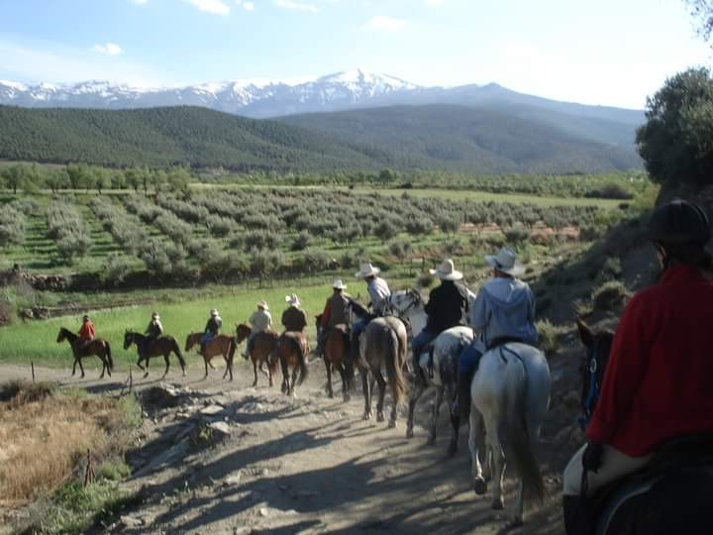

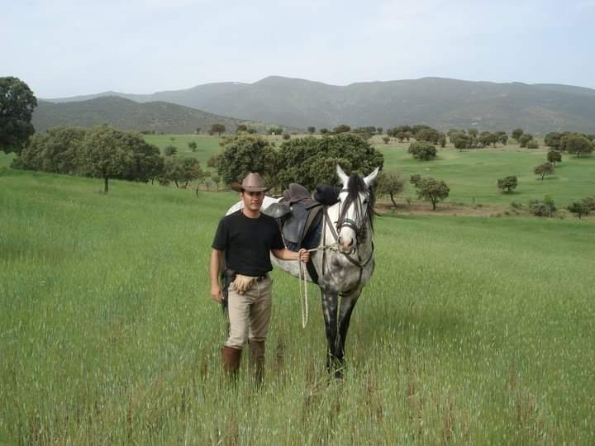

**DAY 5. May 5th / Sunday Jerez del Marquesado - Alquife Mines - La Calahorra.**

Today we head east, crossing the immense plain known as the Altiplano de Sierra Nevada. This will allow us to have perhaps the best, longest, and most relaxed gallops of the entire week, as its wide clay paths make it very comfortable for our horses.

In the midst of the plateau, we will discover a red mountain that surrounds the iron mines of Alquife, also known as the Marquesado mines or the mining reserve of the Alquife mines. These mines primarily exploit iron ore and constitute the largest open-pit iron mine in Europe, operational since the Bronze Age (3300 BC to 1200 BC).

After the picnic, we head to La Calahorra, which awaits us with the last medieval castle built in Spain before the Renaissance. The Castle of La Calahorra is a true gem of Andalusian historical and artistic heritage, declared a Cultural Heritage Site (BIC) since July 6, 1922.  
  
**Lunch at a local restaurant. Total duration of the horseback journey / Approx. 4 hours. Dinner and Accommodation: Hospedería del Zenete 4****.**

**DAY 6. May 6th / Monday La Calahorra - Valle del Zalabí - Lugros.**

We descend on our horses, with the Castle of La Calahorra standing witness to our departure, situated on a hill from which the entire Marquesado de Cenete can be seen. Built between 1509 and 1512 on the ruins of an Arab fortress as evidence of the conquest of the Nasrid Empire.

Continuing our horseback journey for the day, we descend from the plateau (1200 meters) to the Valle del Zalabí through a green landscape surrounded by cultivated fields. In times past (during the Andalusian period), these fields were used to cultivate mulberry trees and feed the silkworms used to produce silk for the dresses of Muslim sultans who inhabited Andalusia.

**Lunch in a picnic within the Red Valley, in El Marchal.**

**Accommodation at Hotel Palacio de Oñate **** or similar.**

**Items included on this day:**

**Breakfast - Horseback journey - Picnic lunch - Transfer of riders to the hotel - Dinner - Accommodation.**

*Dinner with a gastronomic and local wine tasting experience.*

**DAY 7. May 7th / Tuesday Lugros - Fin del Mundo - Lugros (End of the Journey)**

After breakfast, transfer of riders to the point where our horses are located.

On the last day of our journey, we will undoubtedly visit one of the most spectacular spaces in Sierra Nevada, "El Fin del Mundo" (The End of the World). This valley of red clay, formed in the Quaternary by the melting waters of Sierra Nevada, has in its walls the largest inhabited cave complex in the world. (Currently, more than 4000 people live in caves).

In the afternoon, after the horseback journey of the day, we return to Lugros to the estate where we will bid farewell to our horses. We then travel by car to Guadix, a Monumental City, where we will visit the cave neighborhood. In the evening, we will have dinner at a restaurant in the center of Guadix.

**Lunch in a picnic within the Red Valley, in El Marchal.**

**Accommodation at Hotel Palacio de Oñate **** or similar.**

**Items included on this day:**

**Breakfast - Horseback journey - Picnic lunch - Transfer of riders to the hotel - Dinner - Accommodation.**

**DAY 8. May 8th / Wednesday Transfer from Lugros to Puerto de Santa María.**

After breakfast, transfer of riders to Puerto de Santa María / approx. 4 hours. The rest of the day is free to rest and/or explore the beautiful Puerto de Santa María on foot. The port serves as the recreational center of the bay. Throughout the year, the atmosphere is lively, with its beaches, wine cellars, and a wide range of entertainment and dining options, making it a premier tourist destination.

One of its most emblematic buildings is the Castle of San Marcos (10th-14th centuries), originally an Arab mosque and now a beautiful fortress. It is joined by the Monastery of La Victoria and the Main Prioral Church, both in Gothic style. Notable civil architecture includes the Lonja, the Hospital of San Juan de Dios, and the Fountain of the Galleys. Throughout the Middle Ages, the city experienced a progressive maritime boom, leading to the notable participation of its sailors in the discovery and conquest of America. In this city, the sailor Juan de la Cosa drew the first world map in 1500 that included American lands.

**Accommodation at: Hotel Crisol Monasterio de San Miguel 4**** or similar.**

**Food included on this day: Breakfast**.

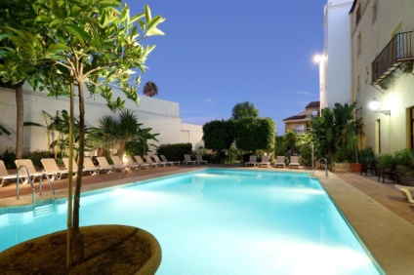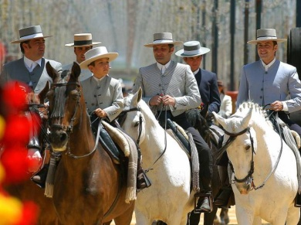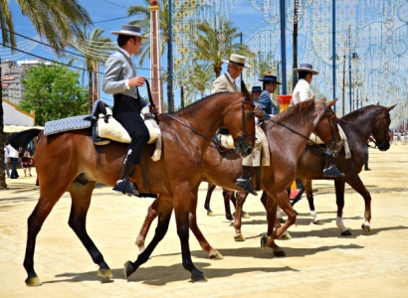

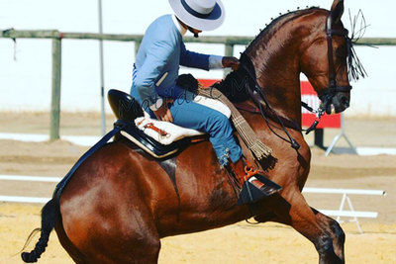

**DAY 9. May 9th / Thursday Bodegas González Byass & Feria del Caballo**

After breakfast, private transfer for a guided tour of Bodegas González Byass, better known as "Bodegas Tío Pepe." It is a monumental set of wineries located in the historic center of Jerez, representing the winemaking tradition of the 19th century with Andalusian courtyards, vine-covered streets, and spectacular centuries-old cellars where the finest Sherries and Brandies age. We will explore its vineyards and gardens, the centuries-old cellars with over 180 years of history, and discover the wonderful flavors and aromas of the best Sherries in a tasting session.

After our visit to the wineries, we continue to Parque González Hontoria, the venue for "La Feria del Caballo" (The Horse Fair), one of the oldest in Spain and undoubtedly one of the most important in the world. Declared of International Tourist Interest, it offers visitors the opportunity to enjoy local wines, the magic of flamenco, and the spectacular horse and carriage parade.

**Accommodation at: Hotel Crisol Monasterio de San Miguel 4**** or similar.**

**Items included on this day: Breakfast - Private transfer to the Wineries - Guided tour and wine tasting at Bodegas González Byass - Private transfer and visit to the Horse Fair - Private transfer to the Hotel.**

**DAY 10. May 10th / Friday Horse Fair & Royal Andalusian School of Equestrian Art**

After breakfast, private transfer to the fairground for another visit to the Horse Fair, with the opportunity for those interested to enjoy parallel equestrian activities at IFECA, such as exhibitions, cattle herding tests, Western riding, carriage displays, morphological contests, etc.

Later, within the Royal Fairgrounds, we can experience the Horse Parade, where the horse is undoubtedly the absolute protagonist. The Royal Fair is adorned with the procession of riders, amazons, and carriages, one of the most attractive and genuine spectacles of the Jerez celebration.In the evening, we will attend the exhibition of the Royal Andalusian School of Equestrian Art, "Como bailan los caballos andaluces" (How Andalusian horses dance). It is undoubtedly the most elegant exhibition of the Royal Andalusian School of Equestrian Art, an authentic equestrian ballet with purely Spanish music and costumes from the 18th century. The performance is based on choreographies extracted from classical and Western riding rehearsals and other works of traditional horsemanship.

**Accommodation at: Hotel Soho Boutique Puerto 4**** or similar.**

**Items included on this day: Breakfast - Private transfer to the Fair - Visit to the Horse Fair - Entry to Equisur - Exhibition of the Royal Andalusian School of Equestrian Art - Transfer to the Hotel.**

**DAY 11. May 11th / Saturday *End of services**

After breakfast, farewell to the riders, and end of our services.

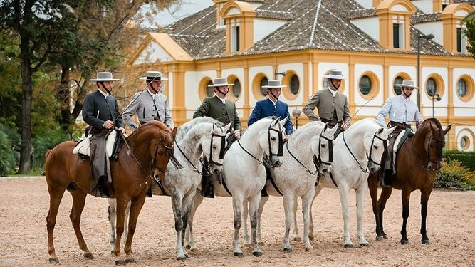

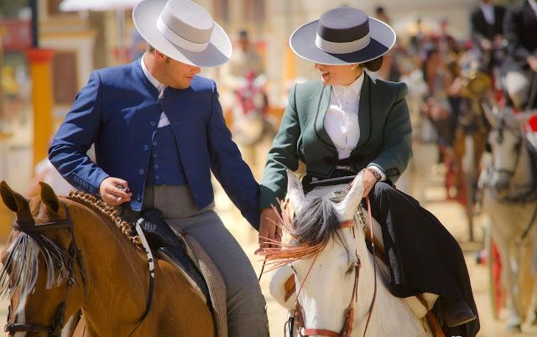

**El precio por persona es de €3,535.**THE PRICE INCLUDES

• 11 Days and **10 Nights of Accommodation** in shared rooms / 5 nights in 4**** hotels

(check-in / Wednesday, May 1 - check-out / Saturday, May 11, 2024)

• Bilingual tour guide specialized in equestrian tourism, accompanying the group throughout the program.

• Welcome Cocktail (Wednesday, May 1)

• Welcome Lunch (Wednesday, May 1)

• **Special 6-day Horseback Journey:** Through the Sierra Nevada Natural Park.

• Trained and fully equipped horses during the horseback journey.

• Bilingual equestrian guide (English, French, Spanish) specialized and certified.

• Support vehicle for luggage transfer during the horseback route.

• Safe, pre-planned, and verified route.

• Itinerant logistics program.

• Official permits.

• Participation diploma.

• Visit to the **HORSE FAIR** (Parque González Ontoria) in Jerez de la Frontera on the days;

Thursday, May 9, and Friday, May 10.

• Visit and tickets to: Equisur and its Select Horse Livestock Morphological Contests on

Thursday, May 9.

**With the possibility of witnessing competitions in:**

- MORPHOLOGICAL P.R.E. SECTION 8TH (4-YEAR-OLD STALLIONS)

- MORPHOLOGICAL ANGLO-ARABIAN BREED

- MORPHOLOGICAL P.R.E. (5 AND 6-YEAR-OLD STALLIONS)

- MORPHOLOGICAL P.R.E. (7-YEAR-OLD AND ABOVE STALLIONS)

- EQUESTRIAN SHOW (*)

- MORPHOLOGICAL P.R.E. MARES 4 YEARS OLD

- MORPHOLOGICAL P.R.E. MARES 5 AND 6 YEARS OLD

- MORPHOLOGICAL P.R.E. MARES 7 YEARS OLD AND ABOVE

- MORPHOLOGICAL P.R.E. FOALS (3 MARES)

• Guided tour and tasting at **Bodegas González Byass**.

• Visit to the **Royal Andalusian School of Equestrian Art**. Gala show,

"Como bailan los caballos andaluces" (How Andalusian horses dance).

• Private local transfers for the group:

Hotel - Horse Fair, Bodegas González Byass, Royal School - Hotel.

• Group long-distance transfers: Guadix - Puerto de Santa María - Jerez de la Frontera.

• Full board. From lunch on Wednesday, May 1, to breakfast on Wednesday, May 8, including a drink during lunch and dinner (beer, cola, wine, or mineral water).

• European breakfast from Thursday, May 9, to Saturday, May 11.

**"THE PRICE DOES NOT INCLUDE"**

• Travel insurance (medical expenses, trip cancellation, etc.)

*It is very important to bring your own insurance with coverage in Spain.

• Airline tickets.

• Entrance fees to museums, exhibitions, galleries, etc., not described in the travel plan.

• Transfer to the meeting point in Cogollos de Guadix.

• Airport transfer In - OUT.

• Transfer In - Out / Bus Station.

• Extra expenses at hotels (alcoholic beverages, telephone, spa, etc.).

• Personal transfers not described in the program.

• Transfers to the starting or ending point.

• Local or international phone calls.

• Additional costs for single or different accommodation than planned in the hotels. The single room incurs an additional charge and is subject to availability.

• Lunch service on May 8, 9, and 10.

• Dinner service on May 8, 9, and 10.

• Changes to the predetermined menus.

• Alcoholic beverages.

• Extra expenses in hotels or restaurants.

• Tips.

• Any other service not described in the program. _____________________________________________________________________

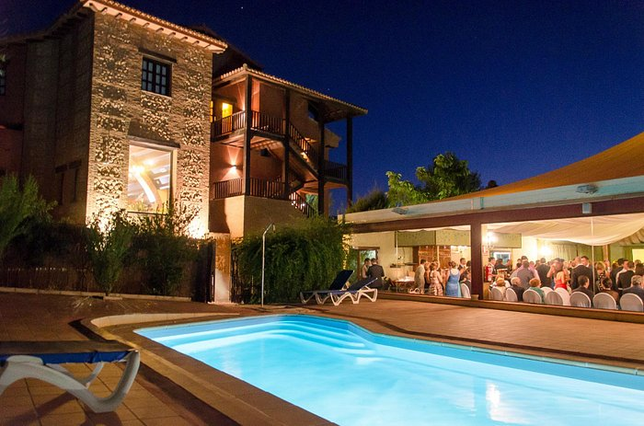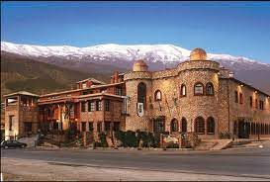

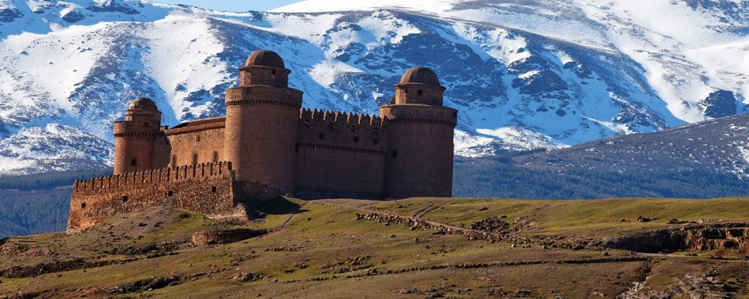

Horse Fair & Equestrian Journey

"Al-Ándalus" 2024

Without a doubt, the best option to experience Spanish equestrian culture and discover the deepest secrets of this wonderful art, in one of the most emblematic countries in the equestrian world.

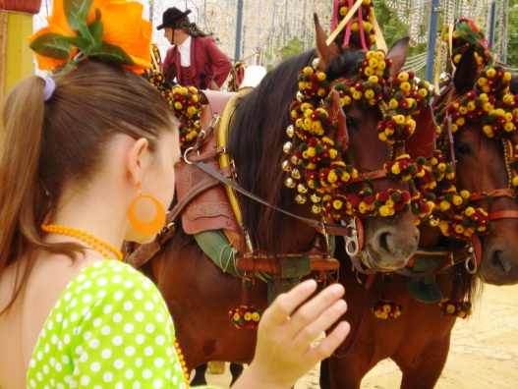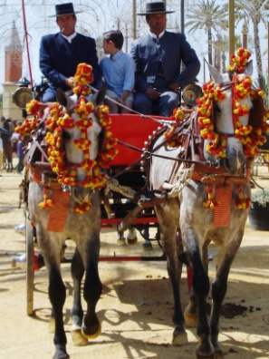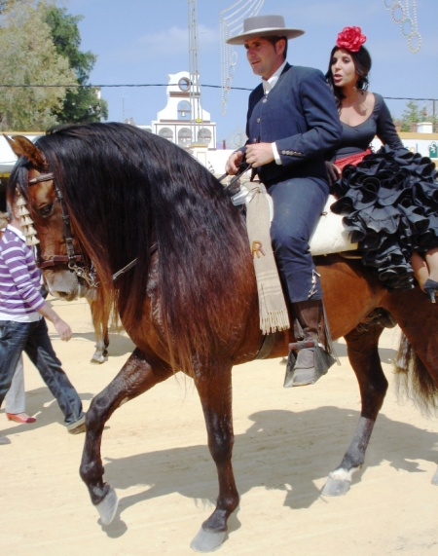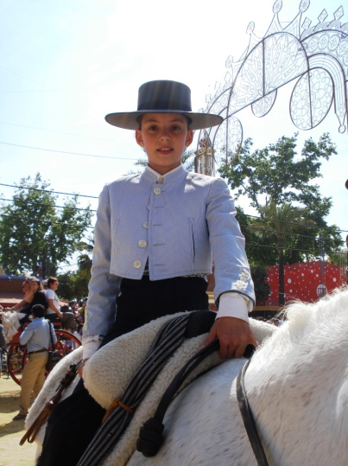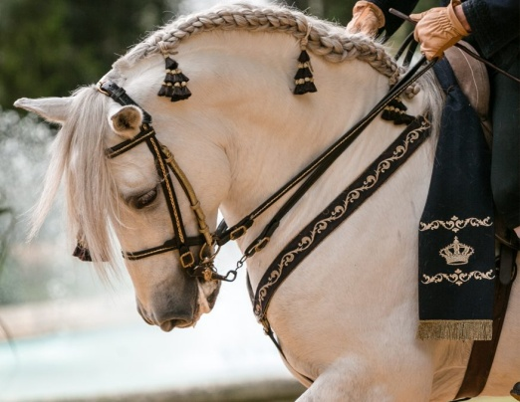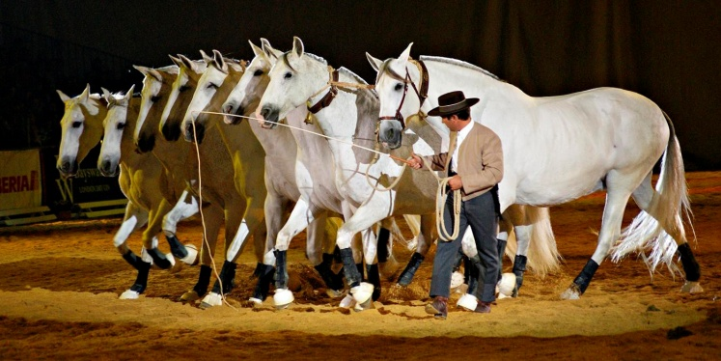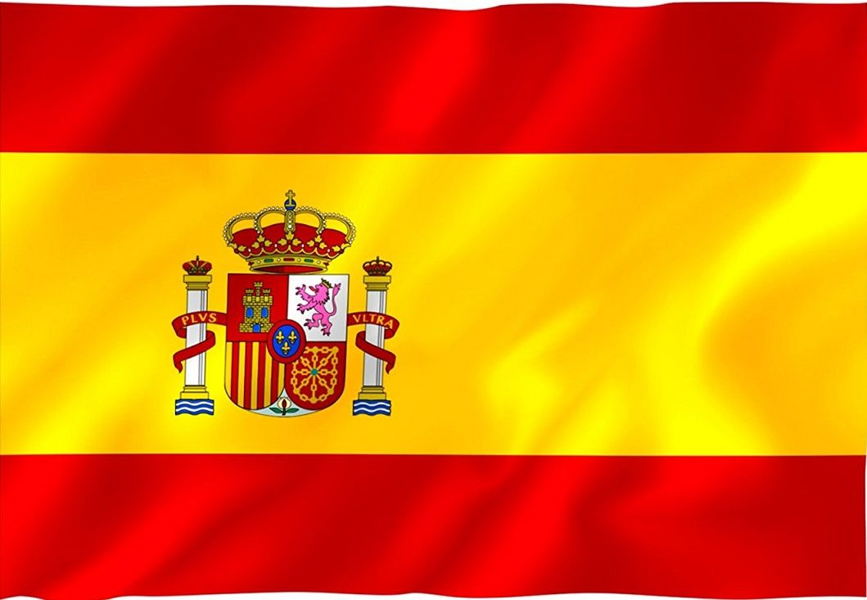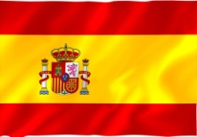

Come ride with us!  
*We are "the experts" in Equestrian Tourism*